ITC HOTELS**

**REVENUE OPTIMIZATION**

**INTRODUCTION**

ITC Hotels is one of India's premier luxury hotel chains, owned by ITC Limited, a diversified conglomerate with interests in FMCG, paperboards, packaging, agribusiness, and information technology. Established in 1975, ITC Hotels has built a strong reputation for offering world-class hospitality with a distinct blend of Indian culture, responsible luxury, and eco-consciousness.

With a portfolio that includes luxury, premium, midscale, and heritage hotels, ITC Hotels operates under multiple brands:

* ITC Hotels – Luxury Collection (luxury segment)
* Welcomhotel (premium)
* Fortune Hotels (mid-market)
* WelcomHeritage (heritage properties)

ITC Hotels is known for its commitment to sustainability, earning global acclaim for its green hotel practices. Many of its properties are LEED Platinum certified, reflecting its “Responsible Luxury” philosophy—where guests enjoy premium experiences without compromising the environment.

With iconic properties in cities like Delhi, Mumbai, Bengaluru, Chennai, Kolkata, Hyderabad, and Jaipur, ITC Hotels seamlessly combines opulence, wellness, Indian traditions, and culinary excellence.

Objectives Of Project

The goal of this project is to create an interactive, multi-page Power BI dashboard to provide stakeholders with real-time insights for decision-making.

* DASHBOARD 1: **Financial Overview & Revenue Performance.**
* DASHBOARD 2: **Occupancy & Capacity Analysis.**
* DASHBOARD3:**Room Category Performance & Booking Insights.**
* DASHBOARD 4: **Cancellations & Lost Revenue Analysis.**

**1. FINANCIAL OVERVIEW&**

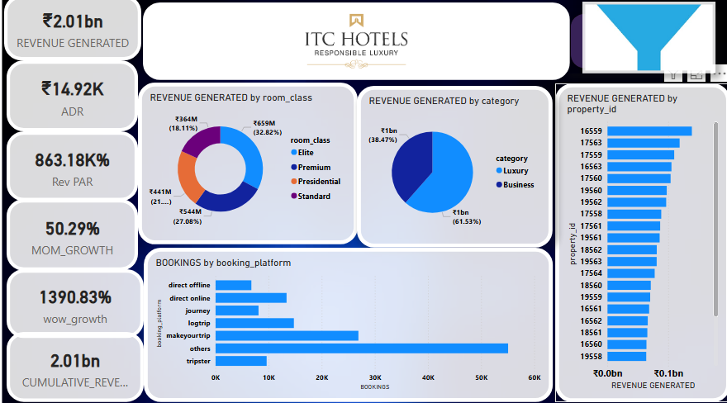**REVENUE PERFORMANCE**

* PROBLEM STATEMENTS:
* What is the total revenue generated by ITC Hotels, and how does it vary across different hotels and room categories?
* What is the cumulative revenue growth over time?
* How has the revenue grown month-over-month (MoM) and week-over-week (WoW)?
* What are the average daily rate (ADR) and revenue per available room (RevPAR)?
  + - A stack of coins with a dollar sign

      AI-generated content may be incorrect.INSIGHTS
* **Total Revenue Generated by ITC Hotels is *Rs.2.01 billon.***

* **Highest Revenue Generated Hotel is *16559 i.e.***

***ITC Exotica.***

* **Most of the revenue is generated by *luxurious rooms category.***
* ***Elite Class Rooms* contribute the most in room class revenue.**

KPIs & METRICS:

* **Total Revenue**
* **Cumulative Revenue**
* **Month-over-Month (MoM) and Week-over-Week (WoW) Growth**
* **Moving Average of Revenue**
* **Average Daily Rate (ADR)**
* **Revenue per Available Room (RevPAR)**

* ***Conclusion:* The analysis of ITC Hotels' financial performance reveals a robust overall revenue stream, with particular room categories and specific properties consistently contributing the most. Revenue has shown a steady upward trend over time, signaling a healthy growth trajectory. While monthly revenue growth tends to be stable, the weekly figures indicate more pronounced fluctuations, suggesting periods of both high demand and potential dips. Performance metrics like Average Daily Rate (ADR) and Revenue Per Available Room (RevPAR) confirm the effectiveness of current pricing and room utilization, providing clear indicators for continued strategic efforts to maximize profitability from available capacity.**

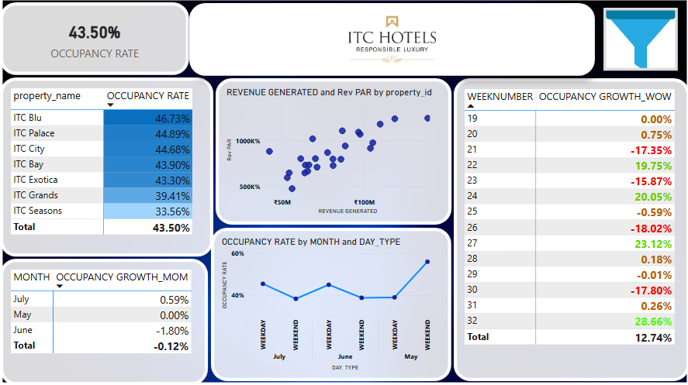**2.Occupancy & Capacity Analysis**

* **PROBLEM STATEMENTS:**
* What is the occupancy rate for each hotel and room category?
* How does occupancy fluctuate seasonally or over specific periods (e.g., weekends, holidays)?
* What is the occupancy growth (MoM and WoW)?
* How does occupancy correlate with revenue and RevPar
* ***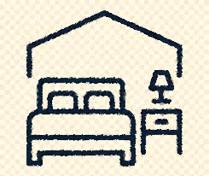*INSIGHTS**
* Occupancy rate ***is 43.50%*** which slightly low, often indicates an opportunity for significant improvement.
* ***ITC Seasons*** properties show the lowest occupancy rates indicating significant room for improvement in filling available capacity.
* ***ITC Blu, ITC Bay & ITC Palace*** tend to have high occupancy rates.
* There is a slight decline in MOM Growth (-1.80) from may to June .This indicates a slightly negative month-over-month trend in occupancy.
* Wow growth shows a decline in week 21 (-17.35%) but recover in week 22 (19.75%), then again experience a decline in weeks 25,26 ,29 & 30 but recovers simultaneously.

KPIs & METRICS:

* **Occupancy Rate**



* ***Conclusion*- An overall occupancy rate of 43% suggests that the hotel(s) might be underperforming in filling their capacity, leading to substantial missed revenue potential. It would be a critical area to investigate for opportunities to boost demand, optimize pricing, and improve marketing efforts to increase room nights sold. Specifically, focus areas for improvement include:**
* **Targeted Promotions: Launch specific campaigns during low-demand periods, especially weekdays, to attract business travelers**
* **Enhanced Marketing Reach: Invest in digital marketing, social media engagement, and partnerships with online travel agencies (OTAs) to increase visibility.**
* **Service Excellence: Ensure a top-notch guest experience to encourage repeat visits and positive word-of-mouth referrals, further boosting future occupancy."**

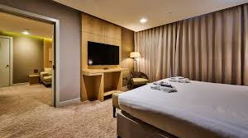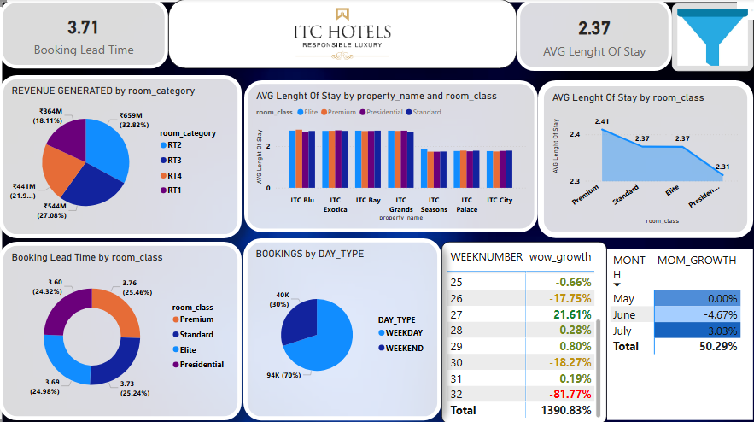3. **Room Category Performance & Booking Insights**

* **PROBLEM STATEMENTS:**
* Which room categories generate the most revenue?
* How do booking patterns (lead time, check-in dates) affect revenue and occupancy?
* What is the average length of stay (ALOS) for each hotel and room type?
* What is the room revenue trend (including running total and MoM/WoW growth)?
* **INSIGHTS**
* ***Rt2 i.e. Elite Rooms*** generates contributes the most in room category revenue.
* Average ALOS is 2.37 days which indicates a short time stays.
* Booking Lead Time is 3.71 days i.e. customers book within short notice.
* Wow trend is unstable & fluctuates every week.
* Mom Growth is low in June(-4.67) but recovers in July again(3.03).
* ALOS is highest for Premium Rooms among the room class (2.41).
* Bookings are made more during weekdays than weekends.

KPIs & METRICS:

* **Average Length of Stay (ALOS)**
* **Booking Lead Time: Average time between booking and check-in.**



* ***Conclusion*- Room Category 2 leads in revenue, yet most bookings occur last-minute, within seven days of check-in. This indicates guests often make spontaneous decisions. While our total revenue is growing steadily, the weekly income fluctuates significantly, making future planning challenging. To improve stability, we should introduce special offers or benefits for advance bookings to shift customer behavior. Additionally, by understanding what makes Room Category 2 so successful, we can apply those insights to other room types. Focusing on targeted promotions during slower weekdays will help boost demand and ensure more consistent earnings."**

4**. Cancellations & Lost Revenue Analysis**

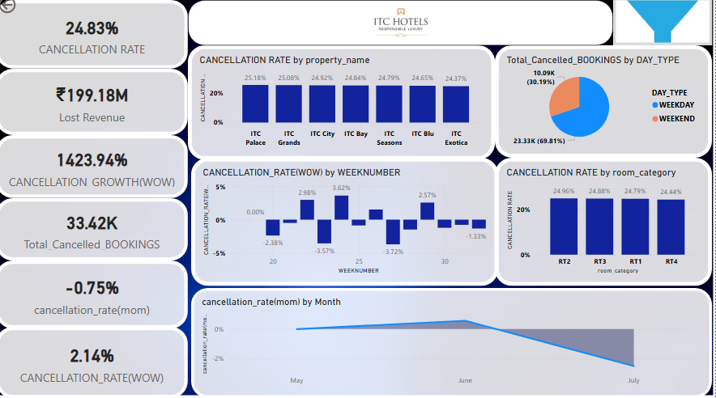

* **PROBLEM STATEMENTS:**
* What is the cancellation rate for each hotel and room category?
* How have cancellation trends changed over time (MoM/WoW)?
* What is the lost revenue due to cancellations?
* Are there any patterns in cancellations (e.g., specific room types, time of year)?
* **INSIGHT**
* *Total cancellation is 33.42 k* which resulted *into Lost Revenue of 199.18 M.*
* **After a slight decrease in May, the *cancellation rate* saw a minor increase *in June(o,57%)* before decreasing again in *July (-2.51%).*
* *Cancellation rate wow* fluctuates rapidly, most of the cancellations are observed in *week 24 (3.62%)* and least in *week 27(-3.72%).*
* There is very minor difference among the cancellation rate by property name and room categories.

KPIs & METRICS:

* *Cancellation Rate:*
* *Lost Revenue due to Cancellations:*
* *Cancellation Growth (WoW)*
* *Cancellation rate (mom)&(wow)*



* ***Conclusion*- The analysis of cancellations reveals an exceptionally high cancellation rate across all hotels and room categories, a pattern that warrants immediate investigation into the underlying data to ensure its accuracy. This widespread cancellation behavior suggests a significant challenge for revenue stability, as a substantial portion of anticipated income is being lost. While the cancellation rates show some variation over different periods, they consistently represent a considerable proportion of bookings, highlighting a persistent issue rather than an isolated occurrence. Addressing this pervasive cancellation trend is crucial for improving financial performance and requires a focused effort on understanding its root causes and implementing strategies to encourage booking adherence.**

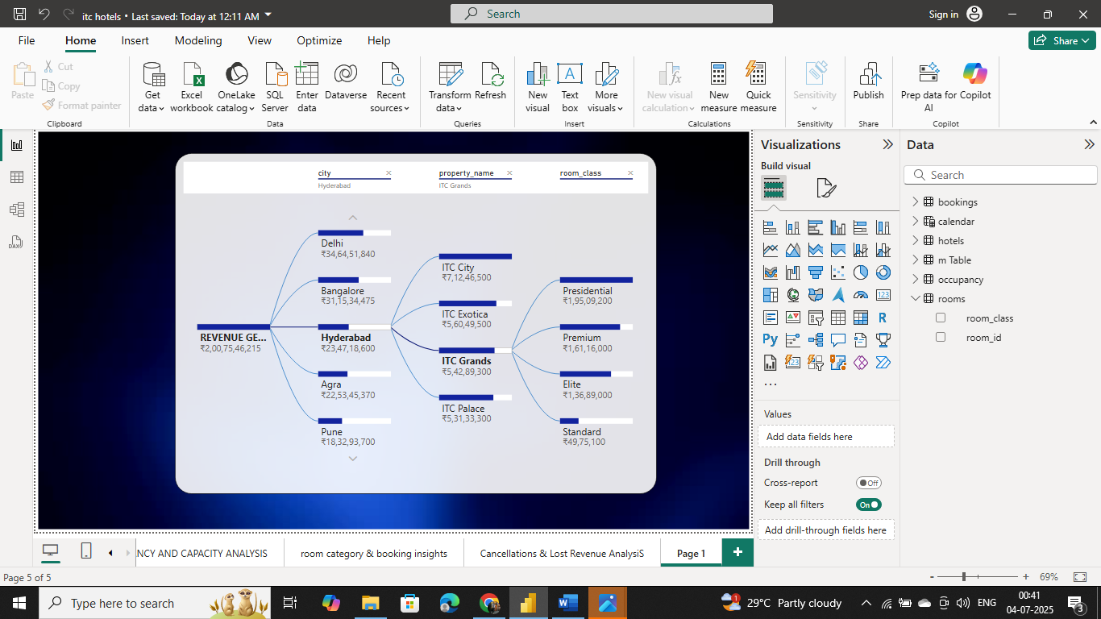

|  |  |
| --- | --- |
| **I. Revenue & Pricing Optimization:**  Recommendation & Improvements   * **Implement Dynamic Pricing:** *Adopt a flexible pricing strategy that adjusts room rates in real-time based on demand, seasonality, competitor rates, and booking lead times.* * **Optimize High-*Performing Categories:*** *Leverage the popularity of Room Category 2 (RT2) by exploring premium pricing, value-added packages, or exclusive offers to maximize its already significant revenue contribution.* * **Strategic Discounting:** *Use promotions selectively to stimulate demand during low occupancy periods without eroding average daily rates excessively.* | *II***. Demand Generation & Occupancy Improvement***:*   * **Target Weekday** *Demand: Develop specific marketing campaigns and packages (e.g., corporate rates, business travel incentives, local staycations) to significantly boost low weekday occupancy.* * **Expand Marketing Reach:** *Enhance digital marketing efforts, engage more actively on social media, and strengthen partnerships with online travel agencies (OTAs) to increase visibility and attract a broader customer base.* * **Focus on Direct Bookings***: Implement incentives (e.g., loyalty points, exclusive discounts) for guests booking directly through the hotel's channels to reduce commission costs.* |
| *III.* **Booking Behavior & Lead Time Management:**   * **Incentivize Early Bookings:** *Offer discounts or benefits for advance reservations to reduce last-minute reliance.* * **Tailor Offers:** *Create specific packages for segments that book further in advance.* | **IV. Data & Analytics Enhancement:**   * **Improve Data Consistency:** *Ensure accurate and complete booking data capture.* * **Track Average Length of Stay (ALOS):** *Prioritize tracking this crucial metric for better inventory and pricing.* * **Regular Monitoring:** *Routinely review KPIs like ADR, RevPAR, and occupancy to guide decisions.* |



Submitted By – Paridhi Bhardwaj

